How to Apply for S-CARD

- Mobile S-CARD can be used from March 1st for Spring Semester and September 1st for Fall Semester
- Functions of S-CARD: Allows you to access the library & any other buildings and to get a discount at on/off campus member stores (ex. cafeteria).

- Types of S-CARD

Type | Application Procedure | Note
S-CARD  (Only ID) | Visit Student Help Center (Bldg.67, 2nd floor) with an official ID (i.e. Passport, Alien Registration Card). | Bring a ID photo  or send it to the Student Help Center by  e-mail (student@snu.ac.kr) with  Name / Department / Student Number /  Contact number.
S-CARD  (ID + Debit Card) | Visit on campus Woori bank with passport or alien registration card and then  visit the Student Help Center.  * Please note that it is not applicable to  International Exchange/Visiting Students.
Mobile  S-CARD | Download ‘Seoul National University’ Application (Google Play or App Store).  → Log in with your mySNU Portal ID & Password → Click the “ ” icon. | <Full-time students>  You must apply for a card-type S-CARD first within a month after the beginning of semester; otherwise, your mobile S-CARD will not work.  <Exchange/Visiting students>  You can use mobile S-CARD even  when you do not have a card-type S-CARD.
NFC  function | NFC function can be issued when you get you Mobile S-CARD issued | Only allowable to Android users.  1. Turn on the NFC mode of your cell phone and tag the back of your phone to the reader.  2. Turn on the screen of your cell phone and retry if it does not work.
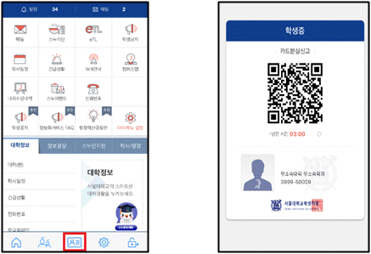
- How to use Mobile S-CARD

- Student Help Center(Division of Student Affairs)
- Location: 2nd floor of Building #67 (Du-re-mun-ye-gwan) / E-mail: student@snu.ac.kr

